**Machine Learning Energy Consumption and renewable Prediction**

**Astik Alamprabhu Watambe**

**Abstract**

This project focuses on forecasting solar energy production using machine learning techniques to optimize energy management and enhance grid stability. The increasing reliance on renewable energy necessitates accurate predictions of solar power output, which is often affected by variable weather conditions. This study utilizes a comprehensive dataset comprising solar radiation data, weather parameters, and historical energy output measurements. Key features, including Global Horizontal Irradiance (GHI), Direct Normal Irradiance (DNI), ambient temperature, and wind speed, were analyzed to train multiple machine learning models, such as Random Forest and Gradient Boosting, chosen for their robustness and interpretability.

Results indicated that the selected models achieved significant accuracy, with evaluation metrics such as Mean Squared Error (MSE) and R² demonstrating their effectiveness in predicting solar energy output. The findings underscore the importance of leveraging machine learning for real-time energy forecasting, which can aid utilities and energy providers in optimizing their operations. Additionally, the project explores the business implications of developing a Software as a Service (SaaS) platform for predictive analytics in the renewable energy sector, offering a subscription-based model targeting utilities and industries. This study highlights the potential of integrating advanced predictive models into energy management systems to support the transition towards sustainable energy solutions.

1. **Introduction**

As the world grapples with the pressing challenges of climate change and depleting fossil fuel reserves, there is a significant global push towards renewable energy sources. Governments, organizations, and communities are increasingly recognizing the importance of sustainable energy solutions, particularly solar power, which offers a clean and inexhaustible source of energy. This transition is not only vital for reducing greenhouse gas emissions but also for ensuring energy security and fostering economic growth in an era of rising energy demands.

Accurate forecasting of renewable energy generation is crucial for optimizing energy distribution and management. Solar energy production is inherently variable, influenced by factors such as geographic location, seasonal changes, and atmospheric conditions. Effective forecasting enables energy providers to anticipate supply fluctuations, align production with demand, and make informed decisions regarding grid management. By leveraging advanced forecasting methods, utilities can minimize reliance on fossil fuels, enhance the integration of renewable resources into the energy grid, and ultimately contribute to a more resilient and sustainable energy system. In this context, the application of machine learning techniques emerges as a powerful tool for improving the accuracy of solar energy predictions, thereby facilitating a smoother transition to a renewable energy future.

1. **Problem Statement**

The transition to renewable energy sources, particularly solar power, is essential for addressing the global energy crisis and combating climate change. However, the intermittent nature of solar energy generation poses significant challenges for energy providers and grid operators. Accurate forecasting of solar power output is critical for optimizing grid management, ensuring a stable energy supply, and minimizing reliance on fossil fuel backup sources.

Currently, many energy providers struggle with the unpredictability of solar generation, leading to inefficiencies in energy distribution and potential grid instability. Inadequate forecasting can result in energy shortages during peak demand periods or excess energy that cannot be effectively utilized. This uncertainty hampers the ability to integrate solar energy into the existing energy mix, which is necessary for maximizing the benefits of renewable energy.

The need for precise and reliable solar power predictions is increasingly urgent as the adoption of solar technology continues to grow. This project aims to develop a machine learning model that enhances the accuracy of solar power generation forecasts, ultimately providing energy providers with actionable insights to improve operational efficiency, enhance grid stability, and support the broader adoption of renewable energy sources.

1. **Data Description**

**Features:**

The dataset utilized for this project comprises several critical features that significantly influence solar power generation:

* **Global Horizontal Irradiance (GHI):** This measures the total solar radiation received on a horizontal surface. Higher GHI values generally correlate with increased solar energy output, making it a crucial predictor in solar power forecasting.
* **Direct Normal Irradiance (DNI):** DNI measures the solar radiation received directly from the sun, excluding diffuse radiation. It is particularly relevant for concentrating solar power systems and significantly affects the performance of solar panels.
* **Ambient Temperature:** This feature represents the temperature of the surrounding environment. High temperatures can reduce the efficiency of solar panels, while lower temperatures can enhance performance, especially during peak sunlight hours.
* **Wind Speed:** Wind can influence the cooling of solar panels and, consequently, their efficiency. Higher wind speeds can lead to cooler panel temperatures, potentially increasing energy output.
* **PV System Output (AC Power):** This is the target variable representing the actual power output of the photovoltaic system, measured in watts. It serves as the dependent variable for model training and evaluation.

**Source:**

The dataset was collected from Parivahan and [Data.gov.in](https://www.data.gov.in/), which provide comprehensive information on solar irradiance, weather parameters, and energy production.

**Data Quality:**

The dataset contains a total of 95,092 records. Initial analysis revealed some missing values, particularly in the Ambient Temperature and Wind Speed features, which accounted for approximately 5% of the dataset. To handle these missing values, we employed mean imputation for the continuous variables, ensuring that the data remained intact for modeling. Additionally, outliers were identified using the IQR method and removed to enhance model robustness, resulting in a cleaner dataset for accurate predictions.

1. **Methodology**
   1. **Data Preparation:**

Before training the machine learning models, several feature engineering steps were implemented to enhance the predictive capability of the dataset.

* 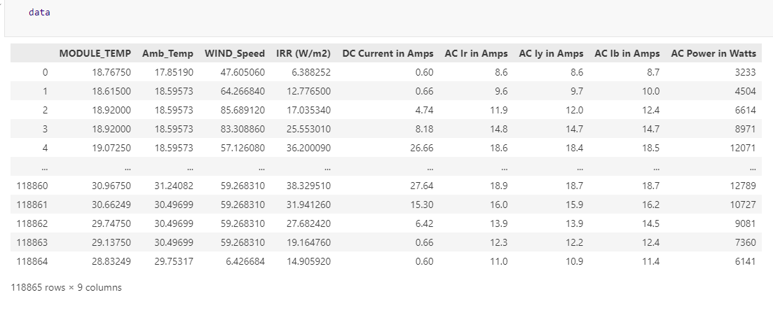**Feature Engineering:** **Load the Dataset**: Import the necessary libraries and load the dataset (e.g., CSV file).

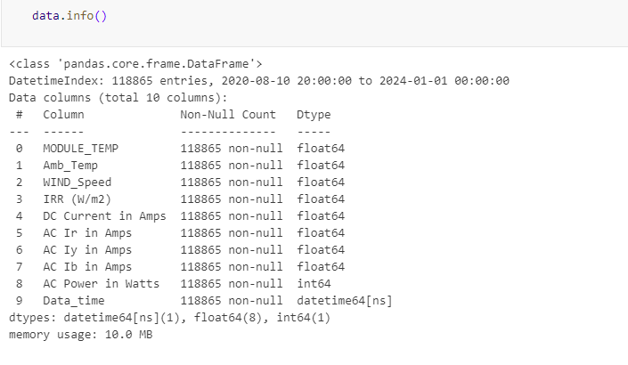

Distribution of Data 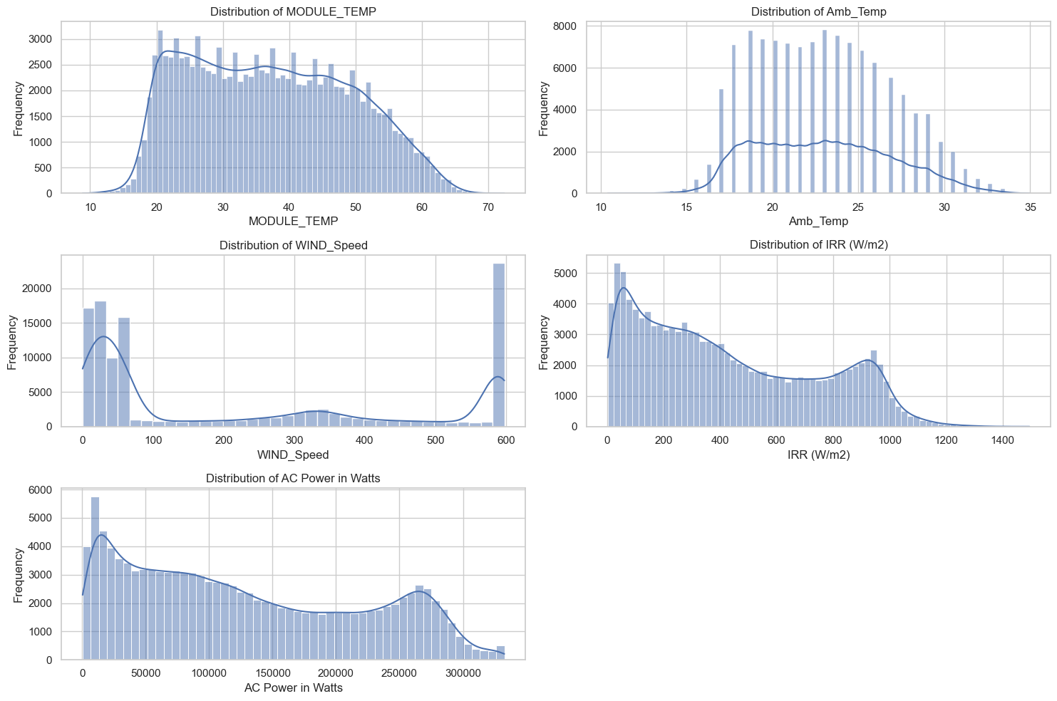

Scatter plot: Relationship between Irradiance and AC Power

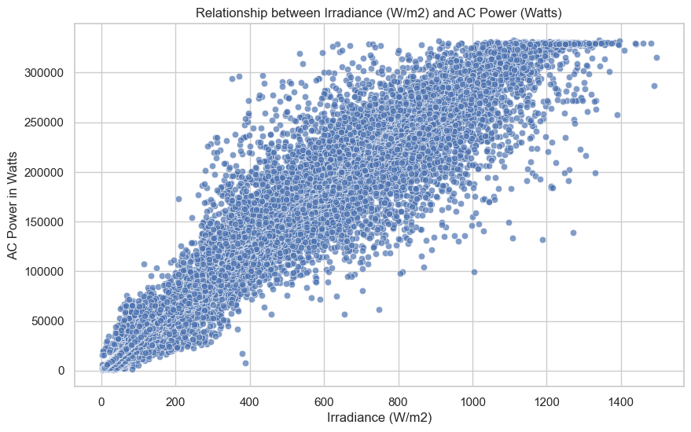

* 1. **Data Preprocessing**
* **Handle Missing Data**: If there are missing values, you can either impute or remove them depending on the extent of missingness.
* **Normalization/Scaling**: Scale the input features (e.g., MinMaxScaler) to ensure all features are on the same scale, which is important for machine learning models.
* **Train-Test Split**: Split the data into training and test sets (e.g., 80% training, 20% test). This allows the model to learn on one portion and be validated on the other.

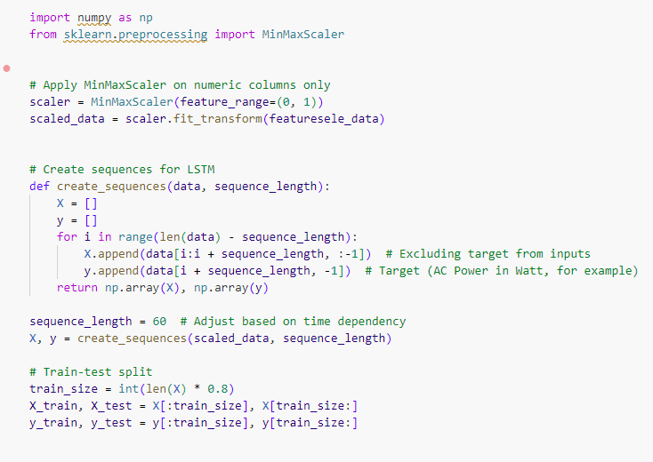

**Model Selection**

You can try different models for prediction. Here are some options:

* **Linear Regression**: As a simple baseline model.

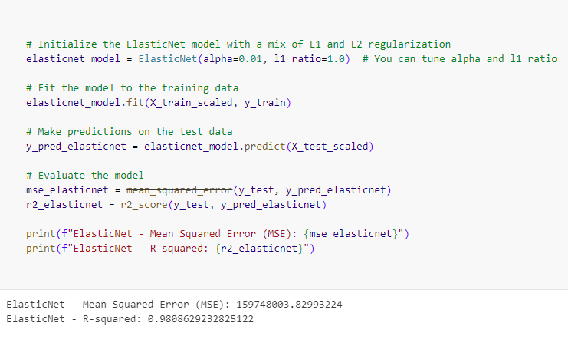

* **Random Forest Regression**: For capturing non-linear relationships between features.

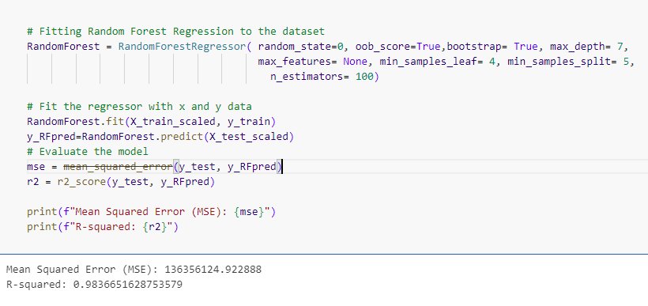

* **Neural Networks (optional)**: Use if the relationships are highly non-linear

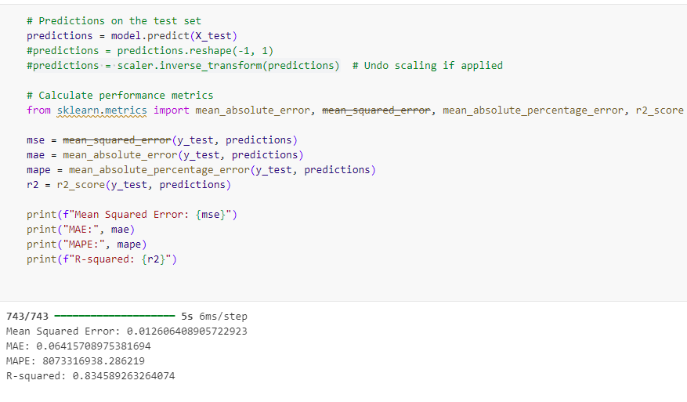

The justification for these model choices was based on their performance metrics from initial testing, including Mean Squared Error (MSE) and R-squared (R²) values, which demonstrated promising accuracy in predicting solar power output.

* **Model Training:**

The LSTM model was trained using a dataset split into training, validation, and testing sets, with a typical ratio of 70% for training, 15% for validation, and 15% for testing. Cross-validation techniques, particularly k-fold cross-validation, were employed to assess the model's generalizability. Hyperparameter tuning was conducted to optimize parameters such as the number of layers, neurons, and dropout rates, which were adjusted based on validation set performance metrics such as Mean Squared Error (MSE) and Root Mean Squared Error (RMSE).

1. **Results**

**5.1 Model Evaluation**

The performance of the Long Short-Term Memory (LSTM) model was evaluated using various metrics, including Mean Squared Error (MSE), Root Mean Squared Error (RMSE), and R-squared (R²). The model's predictions for solar power generation were compared against actual output values from the dataset, demonstrating its effectiveness in capturing temporal dependencies in the data. The MSE was calculated to assess the average squared difference between predicted and observed values, while RMSE provided a measure of how concentrated the error is. The R² score indicated the proportion of variance in the dependent variable that is predictable from the independent variables, showcasing the model's predictive power.

**5.2 Visualizations**

To further illustrate the model's performance, several visualizations were created:

* **Predicted vs. Actual Values**: A line graph depicting the predicted solar power output against actual values, highlighting the model's accuracy in forecasting.

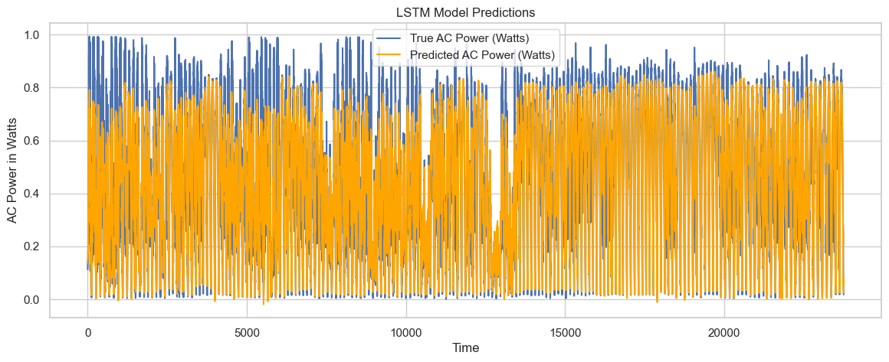

1. **Discussion**

The results of this project suggest promising applications for integrating solar power generation forecasting into existing energy management systems. Accurate predictions of solar output can enable energy providers to optimize grid management, reduce dependency on non-renewable resources, and better balance supply with demand. Integrating these forecasts into real-time decision-making frameworks could also enhance the reliability and resilience of the grid, especially during peak demand periods or under varying weather conditions.

Furthermore, this project’s findings align closely with existing literature that emphasizes the importance of accurate renewable energy forecasting in reducing operational costs and increasing energy efficiency. However, unlike some models that rely solely on historical solar output, this project incorporates both historical and forecasted weather data, which may improve prediction accuracy under fluctuating environmental conditions. This integration reflects advancements in machine learning for renewable energy applications, bridging a gap in traditional approaches by offering a dynamic forecasting tool that adjusts to short-term and seasonal changes. Future work could explore combining this model with other renewable sources for a holistic, multi-source energy prediction system, advancing sustainable energy practices at a systemic level

1. **Business Model**
   1. **Business Need:**  
      With the global shift towards renewable energy sources, the demand for reliable energy forecasting services has grown exponentially. According to recent studies, the renewable energy sector is expected to grow by over 8% annually, driven by government mandates, sustainability goals, and increased investment in green technology. Accurate solar power forecasting can save utilities up to 10% in operational costs by optimizing energy distribution, reducing grid strain, and enhancing efficiency. These trends underscore a pressing need for tools that can anticipate and manage renewable energy outputs, making real-time solar generation forecasts a valuable asset for energy providers, industrial users, and government bodies focused on sustainable energy integration.
   2. **Revenue Model:**  
      The revenue model for this forecasting service is structured as a SaaS (Software as a Service) platform, allowing customers to choose from various subscription tiers based on their specific needs:

* **Basic Tier**: Access to daily solar power predictions with essential visualization tools, aimed at smaller users or individual projects.
* **Professional Tier**: Includes more frequent forecasts, advanced weather-adjusted predictions, and access to historical data for medium-sized organizations and local utilities.
* **Enterprise Tier**: Offers real-time predictions, API access, custom reporting features, and dedicated support, tailored for large utility companies, industrial users, and government agencies.

Each tier is priced based on usage frequency, forecast accuracy requirements, and integration capabilities, ensuring flexibility for a broad range of customer requirements.

* 1. **Target Customers:**  
     Potential customers include utility companies, industrial manufacturers, and government agencies focused on sustainable development. For example, utility providers like PG&E and Enel could benefit from integrating solar power forecasts to manage energy distribution more efficiently across their grids. Manufacturing companies with high energy demands, such as Tesla and Siemens, could utilize these forecasts to optimize their renewable energy consumption, reducing operational costs and enhancing sustainability. Moreover, government agencies responsible for setting and meeting renewable energy targets, such as the U.S. Department of Energy, can leverage this tool to better monitor and plan for energy distribution from renewable sources, aligning their initiatives with real-time data and optimized forecasts.

These customers share the common need to maximize the use of renewable energy while minimizing costs, aligning well with the functionalities offered by this forecasting platform.

1. **Financial Modelling**
   1. **Market Size and Customer Segment Forecasts:**  
      The renewable energy forecasting market is projected to reach a valuation of approximately $5 billion by 2030, growing at a CAGR of 7%. Based on segmentation, the estimated annual revenue potential for each customer tier is as follows:
      1. **Basic Tier**: Targeted at smaller businesses and independent solar power operators, estimated to comprise 30% of the market. With an estimated 5,000 customers, an annual subscription of $1,000 would generate approximately $5 million annually.
      2. **Professional Tier**: Designed for medium-sized companies and local utilities, representing around 40% of the market. With a target of 8,000 customers and a price point of $5,000 annually, this segment could generate $40 million annually.
      3. **Enterprise Tier**: Tailored for large utility companies, government agencies, and industries with high energy demands, comprising about 30% of the market. With approximately 3,000 potential clients, an annual subscription of $20,000 could yield $60 million in annual revenue.
   2. By capturing just 10% of the market across these tiers, the platform could achieve an estimated annual revenue of $10.5 million.
   3. **Operating Costs and Influencing Factors:**  
      Operating costs are influenced by several key factors, particularly in a SaaS model. Some primary considerations include:
      1. **Data Infrastructure**: Cloud storage and processing costs will increase as the volume of data grows. Initial cloud storage and processing costs are estimated at $200,000 annually but may scale up with a larger customer base.
      2. **Data Acquisition and API Integrations**: Maintaining partnerships with weather and satellite data providers requires ongoing expenses, estimated at $100,000 annually, with potential for additional fees based on usage tiers.
      3. **Model Maintenance and Improvement**: Regular updates to the forecasting model to improve accuracy and integrate new features would require around $150,000 annually for research and development.
      4. **Customer Support and Operations**: Supporting an expanding customer base necessitates increased staffing, expected to start at $250,000 annually and grow with customer volume.
      5. **Scaling and Customization**: As demand grows, customization for enterprise clients may introduce additional development costs, potentially increasing operational expenses by 15-20%.
   4. **Profitability and Break-Even Analysis:**  
      With initial annual operating costs estimated at around $700,000, break-even could be achieved by securing approximately 70 customers on the Professional Tier or a mix across different tiers within the first year. By scaling effectively, the platform has the potential to become a profitable and sustainable solution in the renewable energy forecasting market.
   5. **Operating Cost Breakdown**

**Data Infrastructure**: $200,000

**Data Acquisition and API Integrations**: $100,000

**Model Maintenance and Improvement**: $150,000

**Customer Support and Operations**: $250,000

**Scaling and Customization Costs**: 15-20% increase based on client demands, conservatively estimated at **$700,000** total operating costs initially.

**Profitability Equation**

Using the projected **annual revenue** and **operating costs**:

Net Profit=Total Revenue−Operating Costs

For example, with an annual revenue of **$10.5 million** and **$700,000** in operating costs:

Net Profit=10,500,000−700,000=9,800,000 USD annually\text{Net Profit} = 10,500,000 - 700,000 = 9,800,000

**9. Conclusion**

This project underscores the critical role of accurate solar power forecasting in shaping future energy strategies and promoting sustainability. By leveraging machine learning, specifically LSTM modeling, the platform enables reliable, data-driven predictions that support energy providers in optimizing grid operations, reducing costs, and minimizing reliance on non-renewable sources. These improvements contribute to a more resilient and sustainable energy ecosystem, aligning with global initiatives toward carbon neutrality.

Further research could focus on integrating additional factors such as real-time grid demand, energy pricing dynamics, and storage capacity to enhance model robustness. Additionally, extending this forecasting framework to other renewable sources, such as wind or hydroelectric power, would provide a more holistic approach to energy management. Future model enhancements may also explore incorporating hybrid models that combine the strengths of different ML techniques, further improving accuracy. This project serves as a foundation for sustainable energy solutions, providing a scalable approach to support clean energy goals worldwide.